Project
  - Phase1 - Deadline: Sunday 26/07/2026 @ 23:59 Phase2 – Deadline: Sunday 09/08/2026 @ 23:59
[Total Mark is 20]

Web Programming
IT361

Student Details: CRN:
Name:  Name:  Name:  Name: |  | ID:  ID:  ID:  ID:

Instructions:
- You must submit two separate copies (one Word file and one PDF file) using the Assignment Template on Blackboard via the allocated folder. These files must not be in compressed format.
- It is your responsibility to check and make sure that you have uploaded both the correct files.
- Zero mark will be given if you try to bypass the SafeAssign (e.g. misspell words, remove spaces between words, hide characters, use different character sets, convert text into image or languages other than English or any kind of manipulation).
- Email submission will not be accepted.
- You are advised to make your work clear and well-presented. This includes filling your information on the cover page.
- You must use this template, failing which will result in zero mark.
- You MUST show all your work, and text must not be converted into an image, unless specified otherwise by the question.
- Late submission will result in ZERO mark.
- The work should be your own, copying from students or other resources will result in ZERO mark.
- Use Times New Roman font for all your answers.

Description and Instructions
Learning Outcome (1, 2,3, 5,6):
Describe methods and tools in web development.
Create web pages using HTML5 and CSS3.
Develop dynamic web pages using JavaScript.
Create Rich Internet Applications.
Build web applications using PHP and MySQL.

Project Idea: “Campus Events Hub”
Each group will design and build a small dynamic website for a fictional university club or department that publishes upcoming campus events (workshops, seminars, competitions, trips) and lets students register for them online. The site is built with HTML and CSS for the front end, and basic PHP for the dynamic parts (page templates, form handling, validation, and saving registrations).
Group size: 3–4 students. Duration: 6 weeks.

Functional Requirements (Minimum)
The website must contain at least the following pages:
- Home page: introduction to the club/department and highlights of the next 3 upcoming events.
- Events page: a list of all events, generated by PHP from a data source (PHP array, text/CSV file, or a simple database table — the group chooses).
- Event details page: one page that displays the details of a selected event (using a GET parameter, e.g. event.php?id=3).
- Registration page: an HTML form (name, student ID, email, selected event) processed by PHP with server-side validation; valid registrations are appended to a text/CSV file or database table, and a confirmation message is shown.
- Registrations list page: a page that reads the stored registrations and displays them in an HTML table.
- About / Contact page: team members and a simple contact form (validation only; no email sending required).

Technical Requirements

HTML
- Valid, semantic markup (header, nav, main, section, footer); correct use of headings, lists, tables, images, and links.
- At least one data table and at least two forms with appropriate input types and labels.

CSS
- One shared external stylesheet (no inline styles except where justified).
- A consistent color scheme and typography, a styled navigation bar, and hover/focus states.
- A basic responsive behavior (e.g., layout adapts on small screens using media queries or flexible units).

PHP
- Shared header and footer using include/require on every page.
- Handling of GET and POST data with server-side validation (required fields, email format, etc.) and clear error messages.
- Reading and writing data (text/CSV file or a simple database table) and displaying it with loops.
- Code is organized, indented, and commented; no frameworks or site builders are allowed.
Timeline
- Week 1: team formation, choosing the club theme, sitemap and page sketches.
- Weeks 2–3: static HTML/CSS version of all pages.
- Week 3 (end): submit the mid-project progress report.
- Weeks 4–5: PHP work: templates, forms, validation, data storage and display.
- Week 6: testing, polishing, final report, and submission.

Submission Guidelines and Instructions

1. Mid-Project Progress Report
Each group must submit a short progress report at the end of Week 3, which must include:
- Work completed this period.
- One key decision made during this period.
- One problem encountered.
- Plan for the next period.
- Each group member's input/participation.

2. Weekly Progress Log (Inside the Submission File)
Students must document their progress inside the final submission file itself, in a dedicated section named “Progress Log”. The log must contain one dated entry per week (minimum 5 entries) written at the time of the work, not at the end. Each weekly entry must include:
- Date and week number.
- What was accomplished that week (2–4 sentences).
- Which member did what.
- At least one screenshot of the website or code as it looked that week (screenshots must show a visible date/timestamp, e.g., the system clock or file properties).
What NOT to do: Students must not build the entire project at the last minute and then write the log retroactively. Entries that all look written in one sitting, screenshots without dates, or a log that does not match the final work are treated as red flags regardless of the quality of the final website.

3. Project Artifacts
A separate section in the final report must be named “Project Artifacts” and must include:
- The full source code of the website as a ZIP file (all .html, .css, .php files, images, and any data files), submitted together with the report.
- A short “How to run” note (e.g., which folder to place in XAMPP/htdocs and which page to open first).
- The Progress Log section described above, with its screenshots.

4. Written Reflection (End-of-Project Report)
The final report must end with a Reflection section (300–500 words), written in the students' own words, addressing some of the following:
- Describe one specific challenge or obstacle you encountered during this project and explain in detail how you identified and resolved it.
- Explain why you chose your specific approach (e.g., CSV file vs. database, page layout technique) over at least one alternative you considered, and what tradeoffs informed that decision.
- If you used any AI tools during this project (e.g., ChatGPT, Claude, Copilot), disclose which tool(s), for what specific purpose (e.g., debugging, grammar checking, brainstorming), and how you verified or modified the output.
- What would you do differently if you were to redo this project with more time or resources?
This section will be evaluated for specificity and consistency with the technical content of the project report.
Important Notes
- AI use: Students may use AI tools (ChatGPT, Claude, Copilot, Gemini, etc.) only for brainstorming approaches, debugging small errors, or proofreading text. AI must not be used to generate the code logic or produce substantial portions of the report or website. Any permitted AI use must be disclosed in the Reflection section. Undisclosed AI use, or AI use beyond this scope (disclosed or not), will result in a zero grade for the entire project.
- Any submission lacking a valid, inspectable Progress Log, or showing evidence of AI generation or plagiarism, will receive a zero grade for the entire project.
- Failure to submit the mid-project progress report as required, or submission of reports found to be fabricated, copied, or AI-generated, will result in a zero grade for the entire project.

Project Rubric (Total: 20 marks)
Component | Points
Final website (functionality, code quality, design) | 10
Final report | 4
Mid-project progress report | 2
Reflection section | 4
Weekly Progress Log (inside the submission file) | Pass / Fail
Total | 20

Answer:

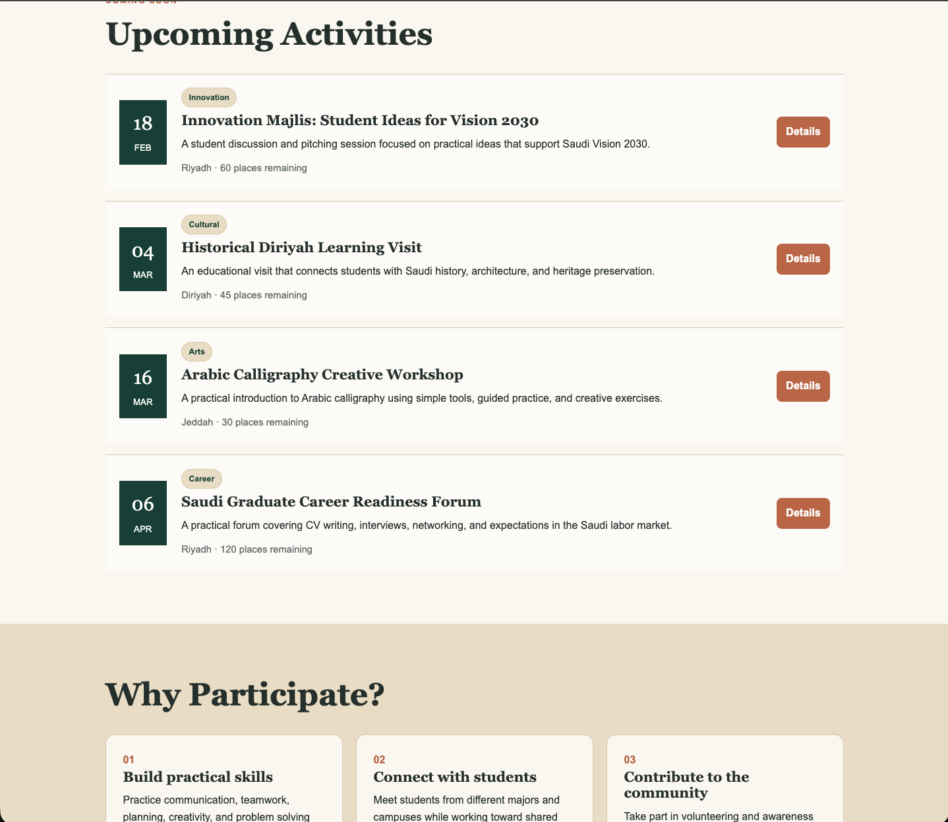
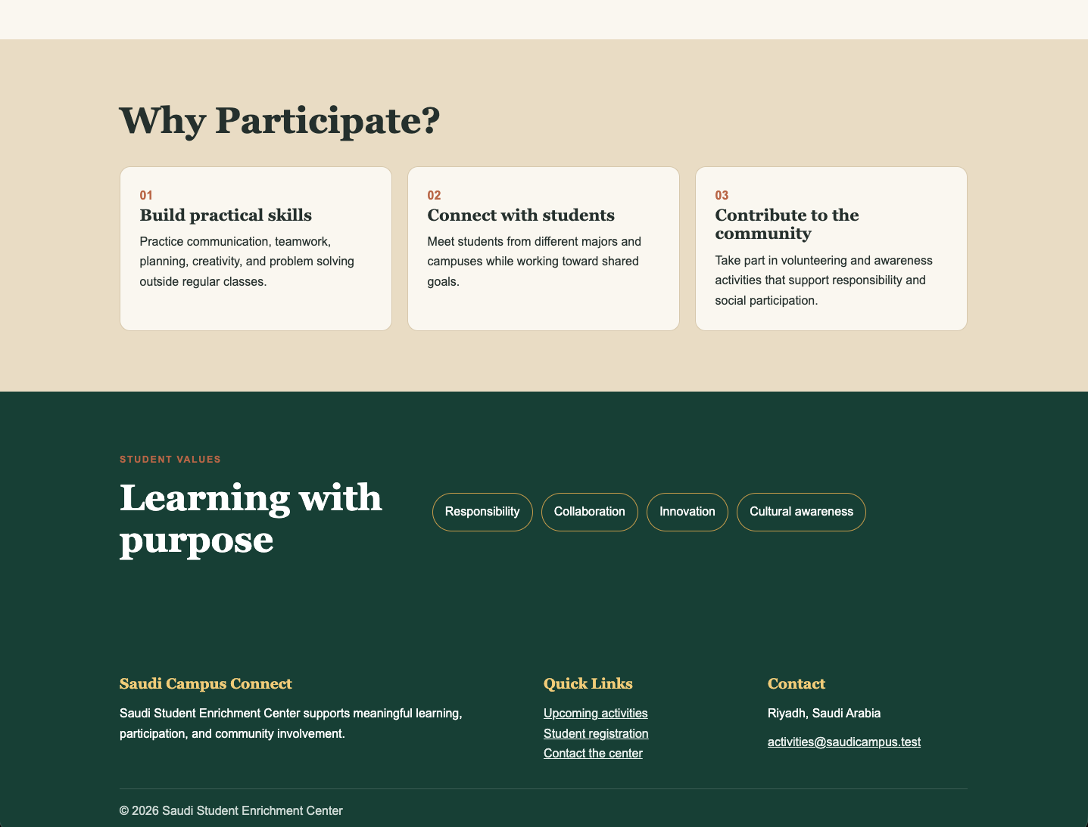


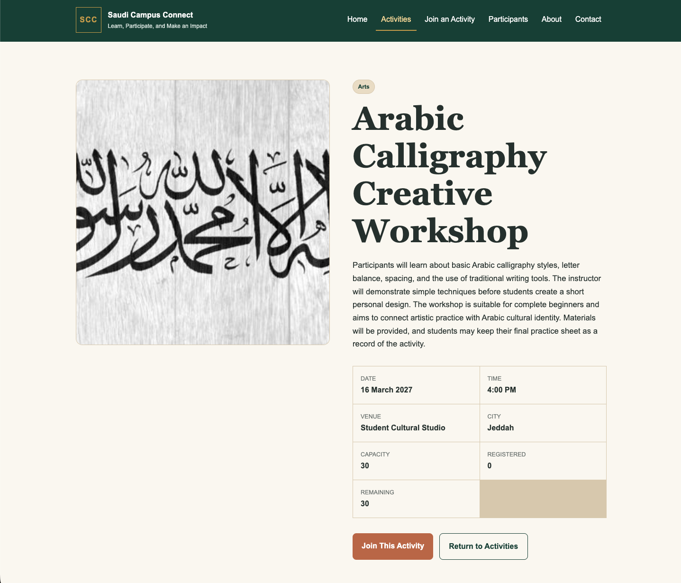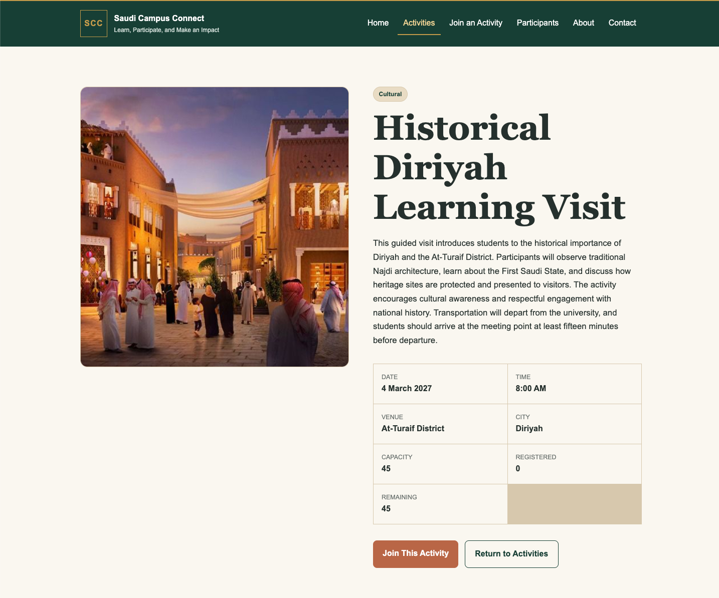
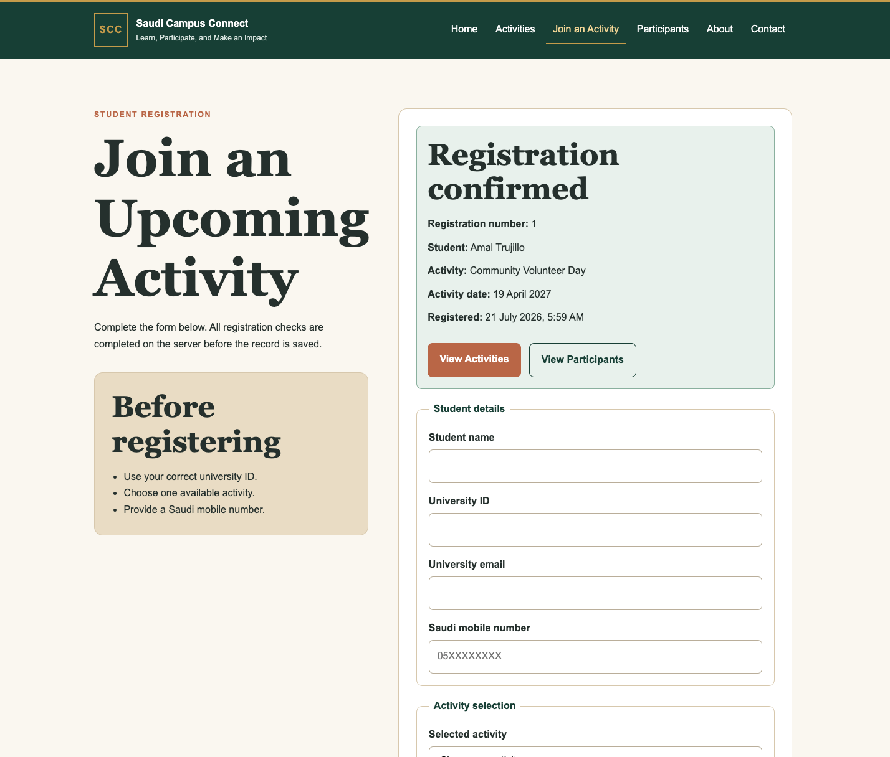
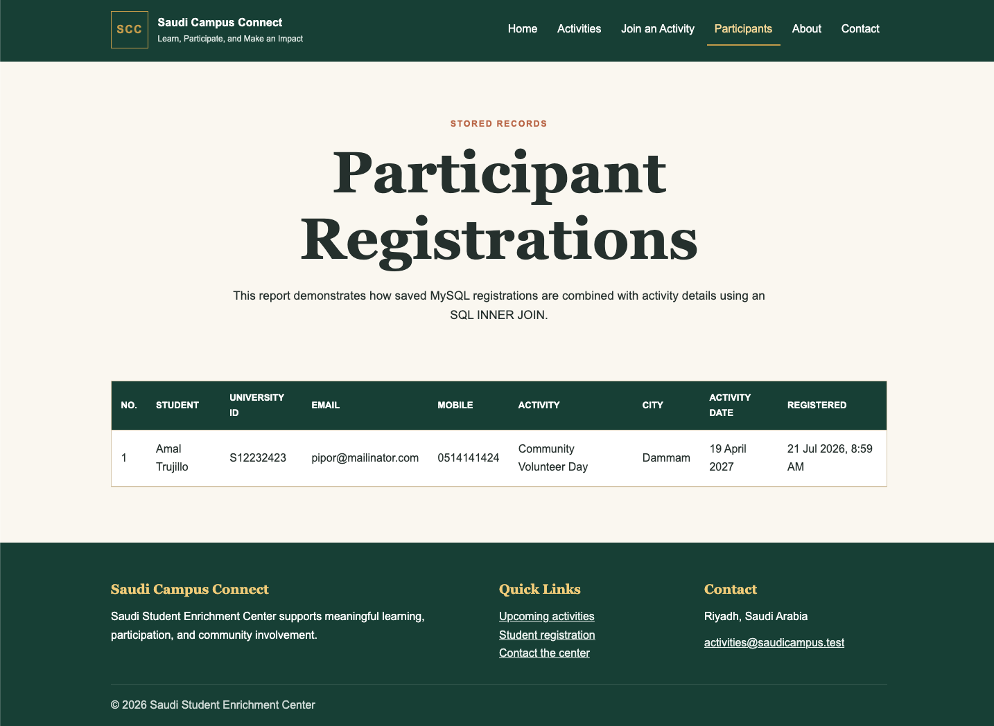

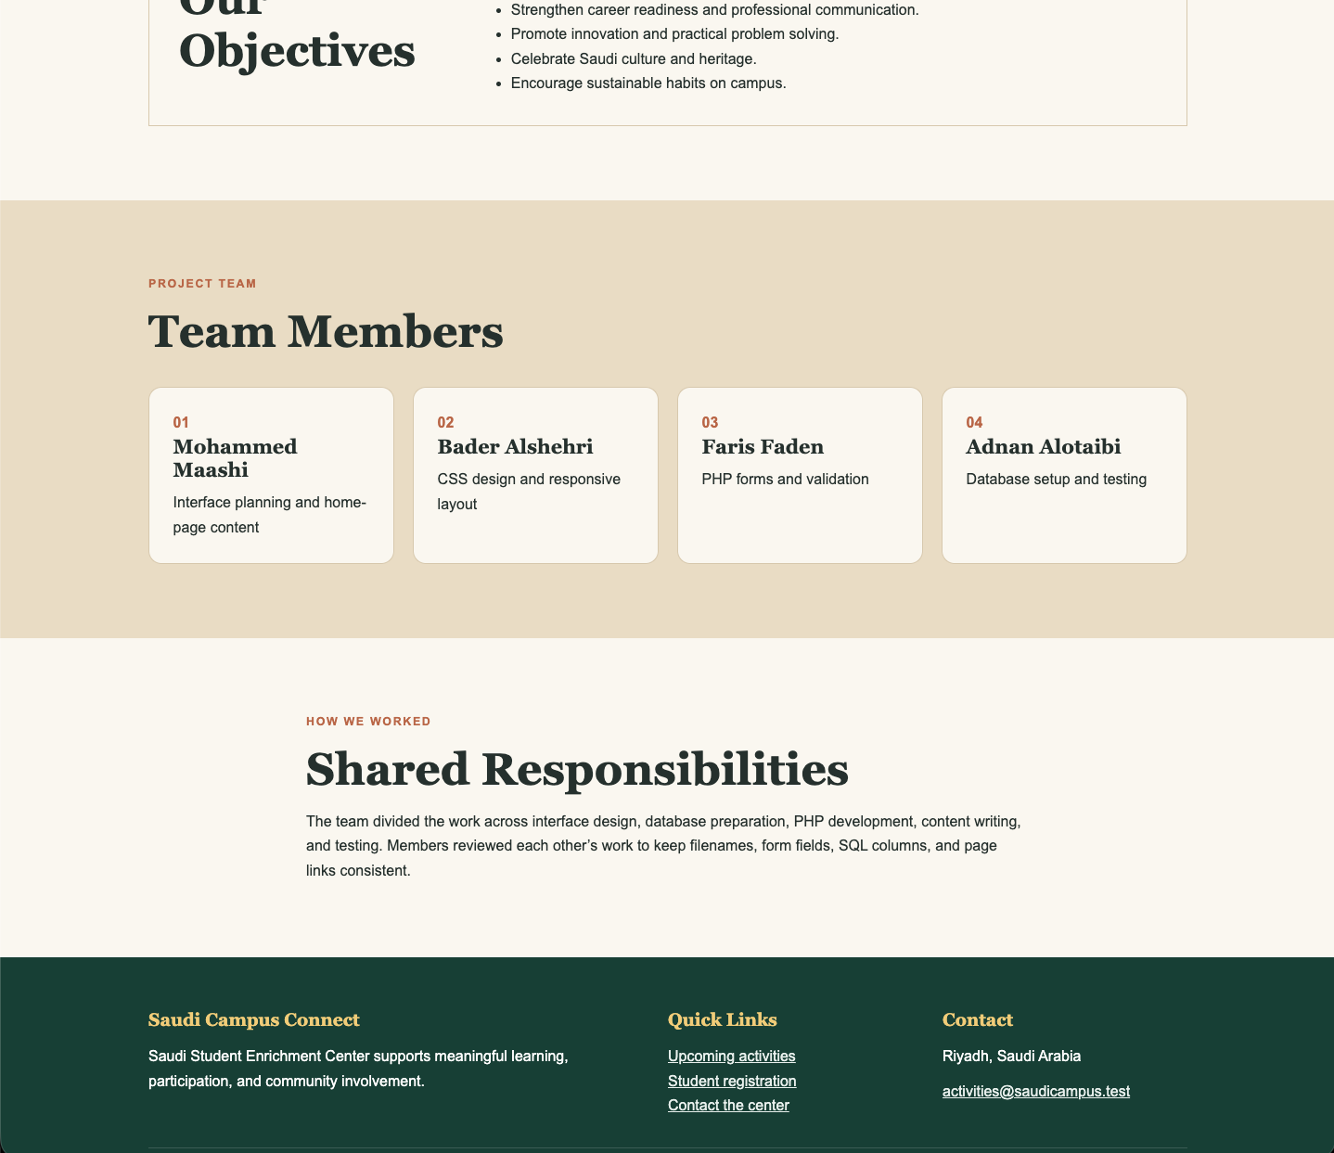
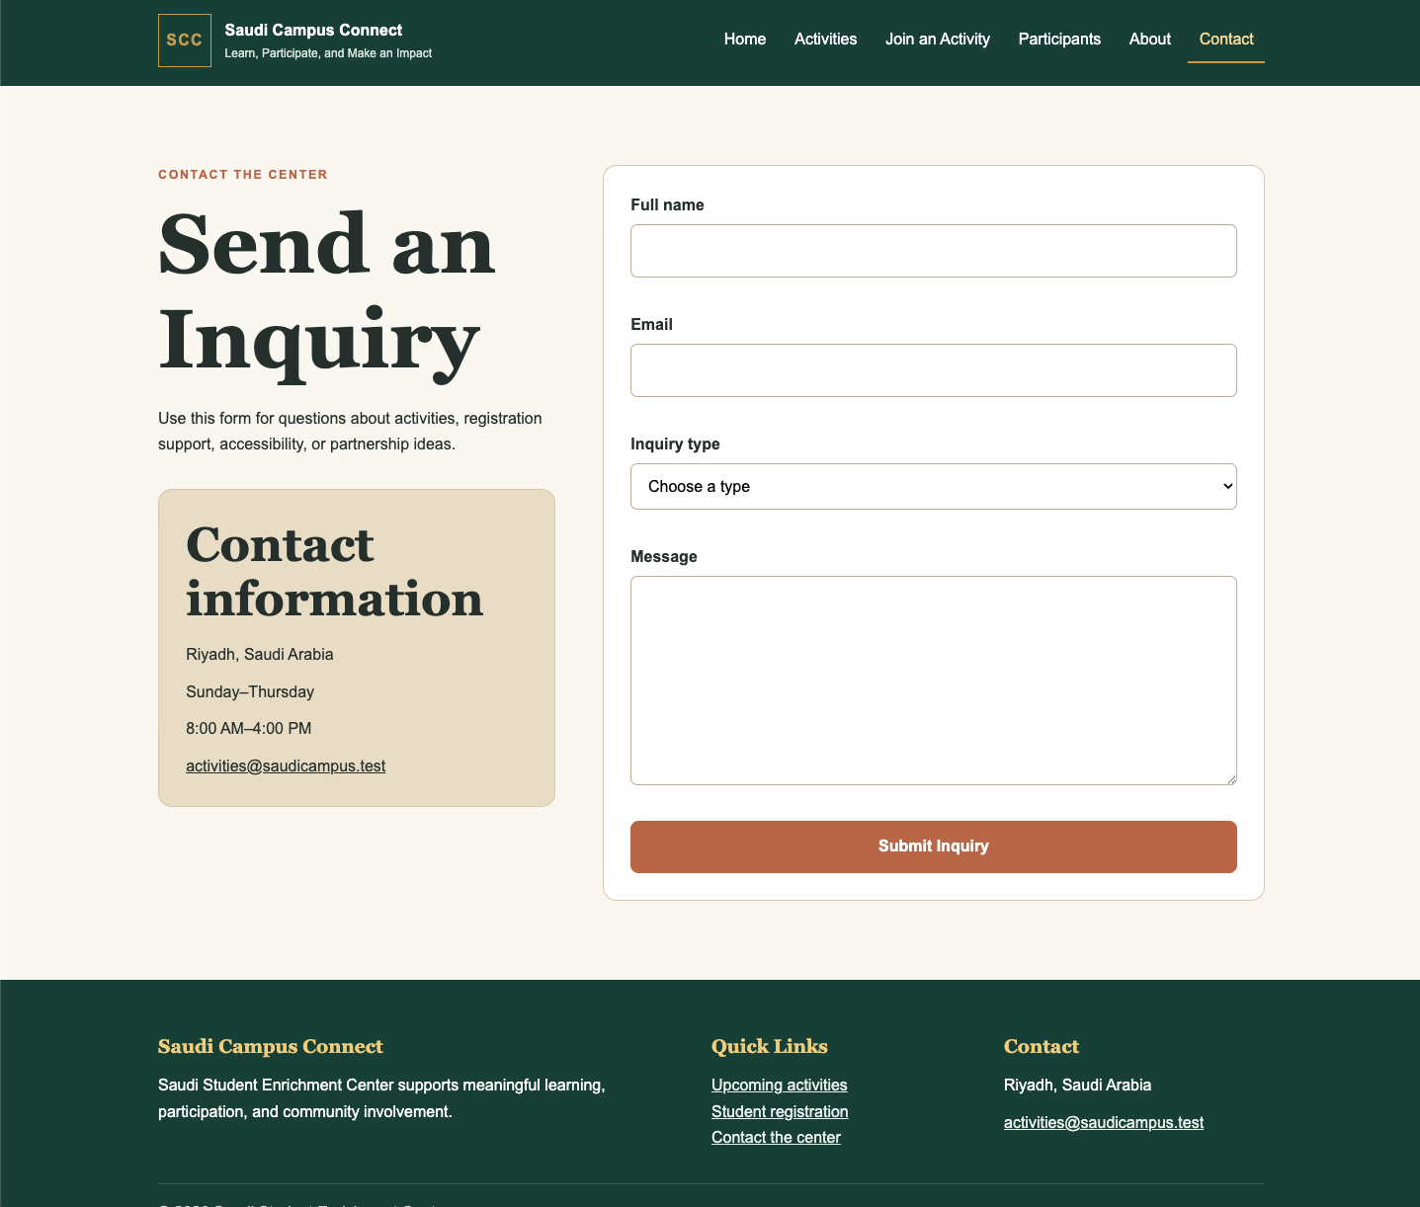

Home Page
<?php
require_once 'includes/db.php';
require_once 'includes/helpers.php';
$pageTitle = 'Home';
$upcoming = getNextActivities($conn, 4);
$featuredResult = getNextActivities($conn, 1);
$featured = mysqli_fetch_assoc($featuredResult);
require 'includes/header.php';
?>
<section class="hero section-space">
<div class="container hero-grid">
<div class="hero-copy">
<p class="eyebrow">Saudi Student Experiences</p>
<h1>Discover Opportunities Beyond the Classroom</h1>
<p>Explore practical, cultural, and community activities created for university students across Saudi Arabia.</p>
<div class="button-row">
<a class="button" href="activities.php">Explore Activities</a>
<a class="button button-secondary" href="join.php">Join an Activity</a>
</div>
</div>
<?php if ($featured): ?>
<article class="featured-panel">
<p class="badge"><?= e($featured['category']) ?></p>
<p class="panel-label">Featured next activity</p>
<h2><?= e($featured['title']) ?></h2>
<dl class="compact-details">
<div>
<dt>Date</dt>
<dd><?= e(formatDate($featured['activity_date'])) ?></dd>
</div>
<div>
<dt>City</dt>
<dd><?= e($featured['city']) ?></dd>
</div>
<div>
<dt>Places</dt>
<dd><?= availablePlaces($conn, $featured) ?> remaining</dd>
</div>
</dl>
<a class="text-link" href="activity.php?id=<?= (int) $featured['id'] ?>">View activity details →</a>
</article>
<?php endif; ?>
</div>
</section>

<section class="section-space">
<div class="container">
<div class="section-heading">
<p class="eyebrow">Coming Soon</p>
<h2>Upcoming Activities</h2>
</div>
<div class="activity-list">
<?php while ($activity = mysqli_fetch_assoc($upcoming)): ?>
<article class="activity-row">
<div class="activity-date-box">
<span><?= date('d', strtotime($activity['activity_date'])) ?></span>
<small><?= date('M', strtotime($activity['activity_date'])) ?></small>
</div>
<div class="activity-row-copy">
<p class="badge"><?= e($activity['category']) ?></p>
<h3><?= e($activity['title']) ?></h3>
<p><?= e($activity['short_summary']) ?></p>
<p class="meta"><?= e($activity['city']) ?> · <?= availablePlaces($conn, $activity) ?> places remaining</p>
</div>
<a class="button button-small" href="activity.php?id=<?= (int) $activity['id'] ?>">Details</a>
</article>
<?php endwhile; ?>
</div>
</div>
</section>

<section class="sand-section section-space">
<div class="container">
<div class="section-heading">
<h2>Why Participate?</h2>
</div>
<div class="benefit-grid">
<article><span>01</span>
<h3>Build practical skills</h3>
<p>Practice communication, teamwork, planning, creativity, and problem solving outside regular classes.</p>
</article>
<article><span>02</span>
<h3>Connect with students</h3>
<p>Meet students from different majors and campuses while working toward shared goals.</p>
</article>
<article><span>03</span>
<h3>Contribute to the community</h3>
<p>Take part in volunteering and awareness activities that support responsibility and social participation.</p>
</article>
</div>
</div>
</section>

<section class="values-section section-space">
<div class="container values-grid">
<div>
<p class="eyebrow">Student Values</p>
<h2>Learning with purpose</h2>
</div>
<div class="value-tags"><span>Responsibility</span><span>Collaboration</span><span>Innovation</span><span>Cultural awareness</span></div>
</div>
</section>
<?php require 'includes/footer.php'; ?>

Activities Page
<?php
require_once 'includes/db.php';
require_once 'includes/helpers.php';
$pageTitle = 'Activities';
$activities = getAllFutureActivities($conn);
require 'includes/header.php';
?>
<section class="page-intro section-space">
<div class="container narrow">
<p class="eyebrow">Programs and Events</p>
<h1>Activities for Saudi University Students</h1>
<p>Browse upcoming learning, cultural, career, volunteering, technology, and sustainability activities.</p>
<div class="category-strip"><span>Innovation</span><span>Cultural</span><span>Arts</span><span>Career</span><span>Volunteering</span><span>Technology</span><span>Sustainability</span></div>
</div>
</section>
<section class="section-space no-top">
<div class="container">
<?php if (mysqli_num_rows($activities) === 0): ?>
<div class="empty-state">
<h2>No upcoming activities</h2>
<p>Please check again later for newly announced opportunities.</p>
</div>
<?php else: ?>
<div class="activity-card-grid">
<?php while ($activity = mysqli_fetch_assoc($activities)): ?>
<article class="activity-card">
<img src="images/<?= e($activity['image_name']) ?>" alt="<?= e($activity['title']) ?>">
<div class="activity-card-body">
<p class="badge"><?= e($activity['category']) ?></p>
<h2><?= e($activity['title']) ?></h2>
<p class="meta"><?= e($activity['city']) ?> · <?= e($activity['venue']) ?></p>
<p class="meta"><?= e(formatDate($activity['activity_date'])) ?> at <?= e(formatTime($activity['start_time'])) ?></p>
<p><?= e($activity['short_summary']) ?></p>
<div class="card-footer-line">
<strong><?= availablePlaces($conn, $activity) ?> places left</strong>
<a class="text-link" href="activity.php?id=<?= (int) $activity['id'] ?>">View Activity →</a>
</div>
</div>
</article>
<?php endwhile; ?>
</div>
<?php endif; ?>
</div>
</section>
<?php require 'includes/footer.php'; ?>

Join Activity Page
<?php
require_once 'includes/db.php';
require_once 'includes/helpers.php';
$pageTitle = 'Join an Activity';
$errors = [];
$success = null;
$name = '';
$universityId = '';
$email = '';
$mobile = '';
$activityId = filter_input(INPUT_GET, 'activity_id', FILTER_VALIDATE_INT) ?: '';
$agreed = false;

if ($_SERVER['REQUEST_METHOD'] === 'POST') {
$name = trim($_POST['student_name'] ?? '');
$universityId = trim($_POST['university_id'] ?? '');
$email = trim($_POST['email'] ?? '');
$mobile = trim($_POST['mobile_number'] ?? '');
$activityId = filter_var($_POST['activity_id'] ?? '', FILTER_VALIDATE_INT);
$agreed = isset($_POST['agreement']);

if (mb_strlen($name) < 3 || !preg_match("/^[\p{Arabic}A-Za-z\s'\-]+$/u", $name)) {
$errors[] = 'Enter a valid student name using letters, spaces, apostrophes, or hyphens.';
}
if (!validUniversityId($universityId)) {
$errors[] = 'University ID must contain 8 to 12 letters or numbers.';
}
if (!filter_var($email, FILTER_VALIDATE_EMAIL)) {
$errors[] = 'Enter a valid university email address.';
}
if (!validSaudiMobile($mobile)) {
$errors[] = 'Enter a Saudi mobile number such as 05XXXXXXXX or +9665XXXXXXXX.';
}
if (!$agreed) {
$errors[] = 'You must confirm that the submitted information is accurate.';
}

$activity = $activityId ? getActivityById($conn, $activityId) : null;
if (!$activity) {
$errors[] = 'Select a valid activity.';
} elseif (availablePlaces($conn, $activity) < 1) {
$errors[] = 'This activity is already full.';
}

if ($activity && duplicateRegistration($conn, $universityId, $activityId)) {
$errors[] = 'This university ID is already registered for the selected activity.';
}

if (!$errors) {
$stmt = mysqli_prepare($conn, "INSERT INTO participants (student_name, university_id, email, mobile_number, activity_id) VALUES (?, ?, ?, ?, ?)");
mysqli_stmt_bind_param($stmt, 'ssssi', $name, $universityId, $email, $mobile, $activityId);
if (mysqli_stmt_execute($stmt)) {
$success = [
'id' => mysqli_insert_id($conn),
'name' => $name,
'title' => $activity['title'],
'date' => $activity['activity_date'],
'registered' => date('j F Y, g:i A')
];
$name = $universityId = $email = $mobile = '';
$activityId = '';
$agreed = false;
} else {
$errors[] = 'The registration could not be saved. Please review the details and try again.';
}
}
}

$activities = getAllFutureActivities($conn);
require 'includes/header.php';
?>
<section class="section-space">
<div class="container form-page-grid">
<section>
<p class="eyebrow">Student Registration</p>
<h1>Join an Upcoming Activity</h1>
<p>Complete the form below. All registration checks are completed on the server before the record is saved.</p>
<aside class="info-panel">
<h2>Before registering</h2>
<ul>
<li>Use your correct university ID.</li>
<li>Choose one available activity.</li>
<li>Provide a Saudi mobile number.</li>
</ul>
</aside>
</section>
<section class="form-card">
<?php if ($success): ?>
<div class="success-message">
<h2>Registration confirmed</h2>
<p><strong>Registration number:</strong> <?= (int) $success['id'] ?></p>
<p><strong>Student:</strong> <?= e($success['name']) ?></p>
<p><strong>Activity:</strong> <?= e($success['title']) ?></p>
<p><strong>Activity date:</strong> <?= e(formatDate($success['date'])) ?></p>
<p><strong>Registered:</strong> <?= e($success['registered']) ?></p>
<div class="button-row"><a class="button" href="activities.php">View Activities</a><a class="button button-secondary" href="participants.php">View Participants</a></div>
</div>
<?php endif; ?>
<?php if ($errors): ?>
<div class="error-message">
<h2>Please correct the following</h2>
<ul><?php foreach ($errors as $error): ?><li><?= e($error) ?></li><?php endforeach; ?></ul>
</div>
<?php endif; ?>
<form method="post" novalidate>
<fieldset>
<legend>Student details</legend>
<div class="field"><label for="student_name">Student name</label><input id="student_name" name="student_name" type="text" value="<?= e($name) ?>" required></div>
<div class="field"><label for="university_id">University ID</label><input id="university_id" name="university_id" type="text" value="<?= e($universityId) ?>" maxlength="12" required></div>
<div class="field"><label for="email">University email</label><input id="email" name="email" type="email" value="<?= e($email) ?>" required></div>
<div class="field"><label for="mobile_number">Saudi mobile number</label><input id="mobile_number" name="mobile_number" type="tel" value="<?= e($mobile) ?>" placeholder="05XXXXXXXX" required></div>
</fieldset>
<fieldset>
<legend>Activity selection</legend>
<div class="field"><label for="activity_id">Selected activity</label><select id="activity_id" name="activity_id" required>
<option value="">Choose an activity</option><?php while ($item = mysqli_fetch_assoc($activities)): ?><option value="<?= (int) $item['id'] ?>" <?= (string) $activityId === (string) $item['id'] ? 'selected' : '' ?>><?= e($item['title']) ?> — <?= e($item['city']) ?></option><?php endwhile; ?>
</select></div>
<label class="checkbox-row"><input type="checkbox" name="agreement" value="1" <?= $agreed ? 'checked' : '' ?>> I confirm that the information entered is accurate.</label>
</fieldset>
<button class="button" type="submit">Submit Registration</button>
</form>
</section>
</div>
</section>
<?php require 'includes/footer.php'; ?>

Participation
<?php
require_once 'includes/db.php';
require_once 'includes/helpers.php';
$pageTitle = 'Participants';
$sql = "SELECT p.id, p.student_name, p.university_id, p.email, p.mobile_number, p.registration_date,
a.title, a.city, a.activity_date
FROM participants p
INNER JOIN activities a ON p.activity_id = a.id
ORDER BY p.registration_date DESC";
$participants = mysqli_query($conn, $sql);
require 'includes/header.php';
?>
<section class="page-intro section-space">
<div class="container narrow">
<p class="eyebrow">Stored Records</p>
<h1>Participant Registrations</h1>
<p>This report demonstrates how saved MySQL registrations are combined with activity details using an SQL INNER JOIN.</p>
</div>
</section>
<section class="section-space no-top">
<div class="container">
<?php if (mysqli_num_rows($participants) === 0): ?>
<div class="empty-state">
<h2>No registrations yet</h2>
<p>Submitted registrations will appear here.</p>
</div>
<?php else: ?>
<div class="table-wrap">
<table>
<thead>
<tr>
<th>No.</th>
<th>Student</th>
<th>University ID</th>
<th>Email</th>
<th>Mobile</th>
<th>Activity</th>
<th>City</th>
<th>Activity Date</th>
<th>Registered</th>
</tr>
</thead>
<tbody>
<?php while ($row = mysqli_fetch_assoc($participants)): ?><tr>
<td><?= (int) $row['id'] ?></td>
<td><?= e($row['student_name']) ?></td>
<td><?= e($row['university_id']) ?></td>
<td><?= e($row['email']) ?></td>
<td><?= e($row['mobile_number']) ?></td>
<td><?= e($row['title']) ?></td>
<td><?= e($row['city']) ?></td>
<td><?= e(formatDate($row['activity_date'])) ?></td>
<td><?= e(date('j M Y, g:i A', strtotime($row['registration_date']))) ?></td>
</tr><?php endwhile; ?>
</tbody>
</table>
</div>
<?php endif; ?>
</div>
</section>
<?php require 'includes/footer.php'; ?>

About Page
<?php
require_once 'includes/helpers.php';
$pageTitle = 'About';
require 'includes/header.php';
?>
<section class="page-intro section-space">
<div class="container narrow">
<p class="eyebrow">About the Center</p>
<h1>Learning Beyond Academic Courses</h1>
<p>The Saudi Student Enrichment Center connects university study with cultural, career, innovation, and community experiences.</p>
</div>
</section>
<section class="section-space no-top">
<div class="container alternating-sections">
<article>
<div>
<p class="number-label">01</p>
<h2>Our Mission</h2>
</div>
<p>Our mission is to help students develop practical skills, social responsibility, confidence, and awareness of Saudi development priorities through accessible campus activities.</p>
</article>
<article>
<div>
<p class="number-label">02</p>
<h2>Our Objectives</h2>
</div>
<ul>
<li>Support student development outside the classroom.</li>
<li>Encourage volunteering and community participation.</li>
<li>Strengthen career readiness and professional communication.</li>
<li>Promote innovation and practical problem solving.</li>
<li>Celebrate Saudi culture and heritage.</li>
<li>Encourage sustainable habits on campus.</li>
</ul>
</article>
</div>

</section>
<section class="sand-section section-space">
<div class="container">
<div class="section-heading">
<p class="eyebrow">Project Team</p>
<h2>Team Members</h2>
</div>
<div class="team-grid">
<article><span>01</span>
<h3>Mohammed Maashi</h3>
<p>Interface planning and home-page content</p>
</article>
<article><span>02</span>
<h3>Bader Alshehri</h3>
<p>CSS design and responsive layout</p>
</article>
<article><span>03</span>
<h3>Faris Faden</h3>
<p>PHP forms and validation</p>
</article>
<article><span>04</span>
<h3>Adnan Alotaibi</h3>
<p>Database setup and testing</p>
</article>
</div>
</div>
</section>
<section class="section-space">
<div class="container narrow">
<p class="eyebrow">How We Worked</p>
<h2>Shared Responsibilities</h2>
<p>The team divided the work across interface design, database preparation, PHP development, content writing, and testing. Members reviewed each other’s work to keep filenames, form fields, SQL columns, and page links consistent.</p>
</div>
</section>
<?php require 'includes/footer.php'; ?>

Contact Page
<?php
require_once 'includes/db.php';
require_once 'includes/helpers.php';
$pageTitle = 'Contact';
$allowedTypes = ['General Question', 'Activity Information', 'Registration Support', 'Accessibility Request', 'Partnership Suggestion'];
$name = $email = $type = $message = '';
$errors = [];
$sent = false;
if ($_SERVER['REQUEST_METHOD'] === 'POST') {
$name = trim($_POST['sender_name'] ?? '');
$email = trim($_POST['email'] ?? '');
$type = trim($_POST['inquiry_type'] ?? '');
$message = trim($_POST['message'] ?? '');
if (mb_strlen($name) < 3) $errors[] = 'Full name must contain at least three characters.';
if (!filter_var($email, FILTER_VALIDATE_EMAIL)) $errors[] = 'Enter a valid email address.';
if (!in_array($type, $allowedTypes, true)) $errors[] = 'Select a valid inquiry type.';
if (mb_strlen($message) < 15 || mb_strlen($message) > 1000) $errors[] = 'Message must contain between 15 and 1000 characters.';
if (!$errors) {
$stmt = mysqli_prepare($conn, "INSERT INTO inquiries (sender_name, email, inquiry_type, message) VALUES (?, ?, ?, ?)");
mysqli_stmt_bind_param($stmt, 'ssss', $name, $email, $type, $message);
if (mysqli_stmt_execute($stmt)) {
$sent = true;
$name = $email = $type = $message = '';
} else {
$errors[] = 'The inquiry could not be saved. Please try again.';
}
}
}
require 'includes/header.php';
?>
<section class="section-space">
<div class="container form-page-grid">
<section>
<p class="eyebrow">Contact the Center</p>
<h1>Send an Inquiry</h1>
<p>Use this form for questions about activities, registration support, accessibility, or partnership ideas.</p>
<aside class="info-panel">
<h2>Contact information</h2>
<p>Riyadh, Saudi Arabia</p>
<p>Sunday–Thursday</p>
<p>8:00 AM–4:00 PM</p>
<p><a href="mailto:activities@saudicampus.test">activities@saudicampus.test</a></p>
</aside>
</section>
<section class="form-card">
<?php if ($sent): ?><div class="success-message">
<h2>Inquiry received</h2>
<p>Thank you. Your message has been stored successfully.</p>
</div><?php endif; ?>
<?php if ($errors): ?><div class="error-message">
<h2>Please correct the following</h2>
<ul><?php foreach ($errors as $error): ?><li><?= e($error) ?></li><?php endforeach; ?></ul>
</div><?php endif; ?>
<form method="post" novalidate>
<div class="field"><label for="sender_name">Full name</label><input id="sender_name" name="sender_name" type="text" value="<?= e($name) ?>" required></div>
<div class="field"><label for="email">Email</label><input id="email" name="email" type="email" value="<?= e($email) ?>" required></div>
<div class="field"><label for="inquiry_type">Inquiry type</label><select id="inquiry_type" name="inquiry_type" required>
<option value="">Choose a type</option><?php foreach ($allowedTypes as $item): ?><option value="<?= e($item) ?>" <?= $type === $item ? 'selected' : '' ?>><?= e($item) ?></option><?php endforeach; ?>
</select></div>
<div class="field"><label for="message">Message</label><textarea id="message" name="message" rows="7" maxlength="1000" required><?= e($message) ?></textarea></div>
<button class="button" type="submit">Submit Inquiry</button>
</form>
</section>
</div>
</section>

<?php require 'includes/footer.php'; ?>

Reflection
During this project, one of the main challenges our group faced was connecting the registration form to the MySQL database while making sure that incorrect or repeated information was not stored. At first, the form appeared to work correctly, but testing showed that a student could submit an invalid mobile number or register for the same activity more than once. We identified the problem by entering different test values and checking the participants table after every submission. To resolve it, we added server-side PHP validation for the student’s name, university ID, email address, Saudi mobile number, selected activity, and agreement checkbox. We also created a duplicate-registration check using the university ID and activity ID. In addition, the system checks the remaining capacity before accepting a registration. This process taught us that a successful form submission does not automatically mean that the data is valid or reliable.
We chose to use a MySQL database instead of storing activities and registrations in a CSV file. A CSV file would have been faster to prepare and easier for a small demonstration, but it would become difficult to manage relationships between activities, participants, and inquiries. MySQL allowed us to connect each participant to an activity through an activity ID and display complete registration records using an SQL INNER JOIN. It also supported prepared statements, duplicate checking, capacity calculations, and organized data retrieval. The tradeoff was that MySQL required more setup, including creating tables, configuring the database connection, and testing SQL queries. However, we believed this additional work produced a more dependable and realistic website.
We used Claude and ChatGPT in a limited way for brainstorming validation test cases, understanding small PHP error messages, and proofreading some written content. We did not directly accept its suggestions without checking them. Any debugging advice was compared with our existing code, tested locally through XAMPP, and modified to match our database columns, page names, and form fields. The group also reviewed the final wording to ensure that it reflected our actual experience and understanding.
With more time, we would improve the system by adding an administrator login, allowing authorized users to create or edit activities, and providing students with the ability to cancel registrations. We would also conduct more testing on different browsers and mobile screen sizes. Another improvement would be adding clearer database error logging and stronger access controls for the participants page, since registration details should not be publicly visible in a real university system.

